LAB EXERCISE 1:
1)CREATE: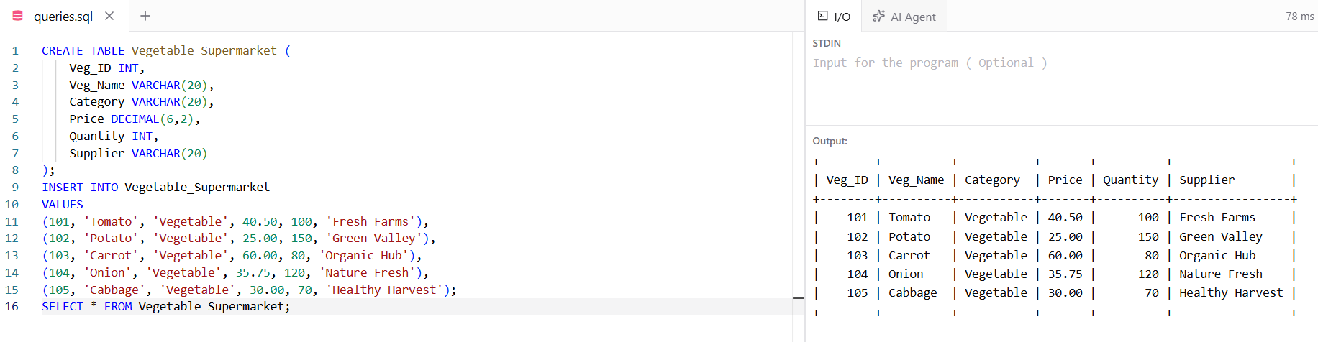
2)ADD
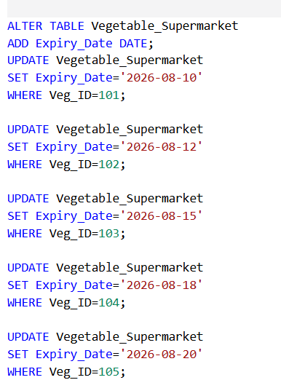
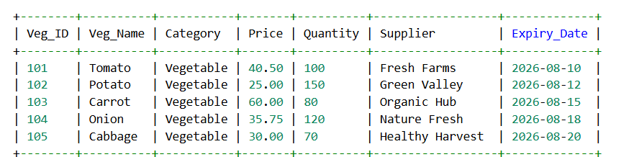

3)ALTER
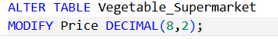
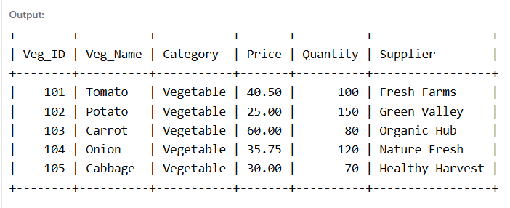

4)DROP
